26

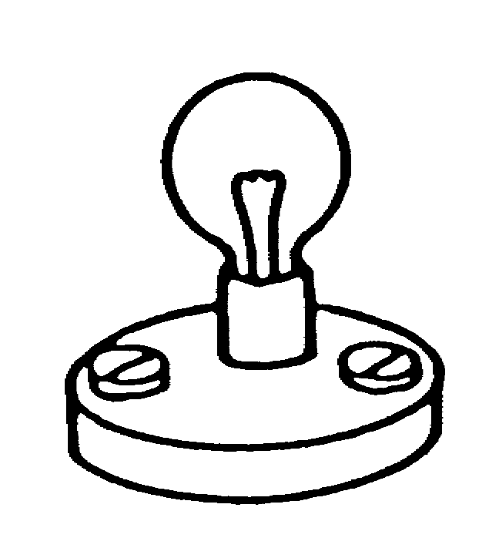
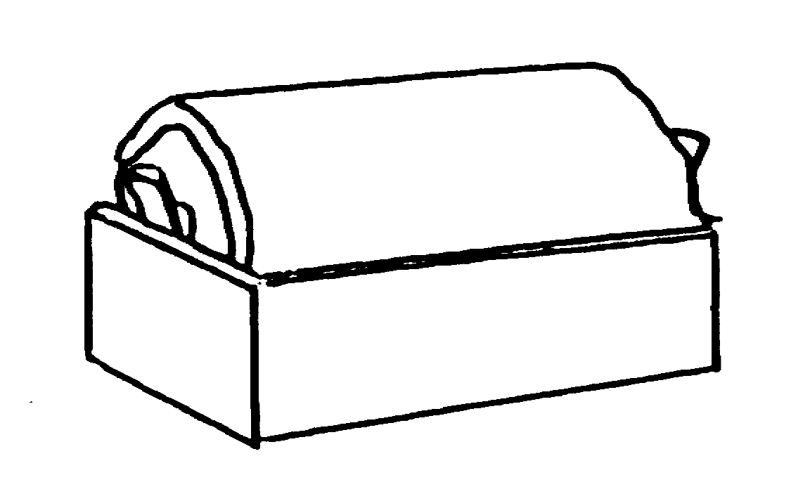
bulb 2
bulb 1
bulb 1

The bulb in this circuit is lit brightly. Another bulb, identical to the first, is added.

(a) How bright are the bulbs now?

Tick ONE box ():

❑ | Bulb 1 is lit. Bulb 2 is out.
❑ | Bulb 2 is lit. Bulb 1 is out.
❑ | Both bulbs are lit. Bulb 1 is brighter.
❑ | Both bulbs are lit. Bulb 2 is brighter.
❑ | Both bulbs are lit, with the same brightness – dimmer than the single bulb.

(b) Which of the following is the best explanation?

Tick ONE box ():

❑ | The battery is not powerful enough to run two bulbs brightly.
❑ | Two bulbs have more resistance than one, so the current is smaller.
❑ | The current now has to be shared between two bulbs.
❑ | The first bulb uses up some of the electric current, so there is less left for the next one.
❑ | The first bulb uses up all of the electric current, so there is none left for the next one.

How confident are you that your answers to this question are correct? Tick ONE box ()

Very confident Fairly confident Not confident Just guessing

